**Institute of Technology Tralee**

**BSc. in Computing with Specialism (Group C) - Year 1**

**Continuous Assessment #1**

**Date: 21/10/11**

**Time: 9 – 11 a.m.**

**Introduction to Programming**

**Instructions:** Attempt the following question. You should use the Just BASIC IDE for coding. When you are finished you must print out your code for correction.

**________________________________________________________**

**Q1.**

The *viscosity* of a liquid is defined as its resistance to flow. So a fluid such as water has a low viscosity since it flows easily, but a fluid such as syrup has a much higher viscosity.

Experimentally, the viscosity of a fluid can be determined by dropping a small sphere (such as a ball-bearing) into the fluid and taking some measurements.

These measurements include the following:

* The density of the ball-bearing
* The density of the fluid
* The radius of the ball-bearing
* The velocity of the ball-bearing

Write a Just BASIC program that determines the viscosity of a fluid using the following formula:

viscosity =

where

pballbearing is the density of the ball-bearing and pfluid is the density of the fluid

g is the acceleration due to gravity, which on Earth is 9.8 m/s/s

a is the radius of the ball-bearing

v is the velocity of the ball-bearing

The program should request the user to supply values for the densities of the ball-bearing and fluid, the radius of the ball-bearing and also its velocity, and then use the formula above to calculate the corresponding viscosity.

The viscosity should then be displayed correct to **2 decimal places** and the program should **allow for at least 4 digits to be displayed before the decimal point** without incurring a logical error.

In reality, the density of the ball-bearing and fluid can only be positive numbers (greater than or equal to zero) and your program should also test to make sure that only positive numbers are accepted for these quantities. If the user does enter a negative number for either of these, the program should immediately issue an appropriate error message and then quit execution, without requesting any further information or performing any other calculations.

Using the test values as indicated in the screen shots below, the program should give you **exactly** the following output when it runs, including banners, blank lines, units etc.

Also note that there will be a few marks awarded for the use of **meaningful variable names**, having a **meaningful comment at the top of the program** and for **proper indentation** in the coding of the program. Also, some marks will be awarded for **efficient** coding and for ensuring that the program is **terminated correctly** to ensure that all resources used by the program are returned to the system upon its completion.

**Sample Screen Shots**

**In this run the densities are both positive**

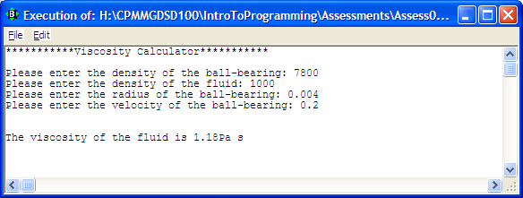

**In this run the ball-bearing density is negative**

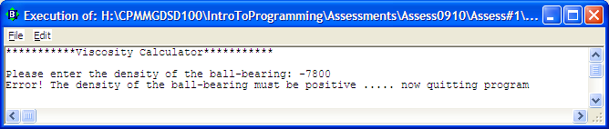

**In this run the fluid density is negative**

